1:

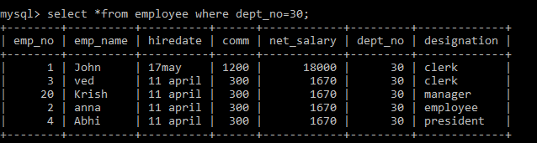

2:

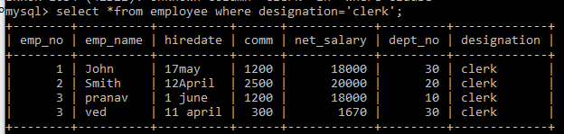

3:

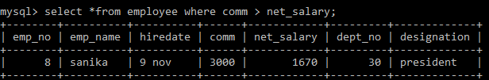

4:

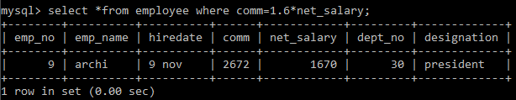

5:

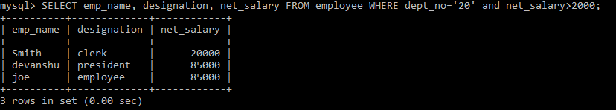

6:

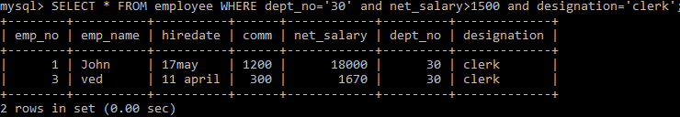

7:

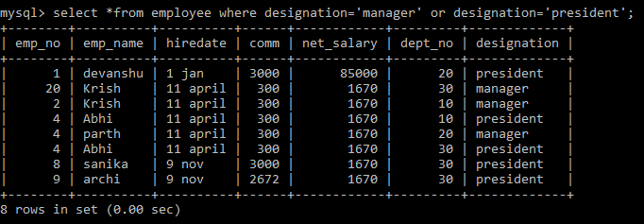

8:

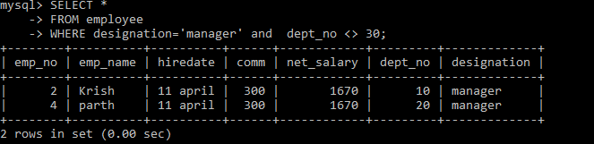

9: Don’t Know

10: Don’t Know

11:

